**Tenancy Visits (aka Reviews) db specifications**

**(Correct as at 31/03/2016)**

**By Alan Thompson**

**Technology and locations**

1. Front-end: MS Access 2003

(do not upgrade to 2010 etc, no need as should be developed easily in ASP.net/MVC/C# or other system from ICT).

1. Front-end Location: \\ohgfile\housing$\Tenant Visits\Db\OHG Tenant Visits.mdb

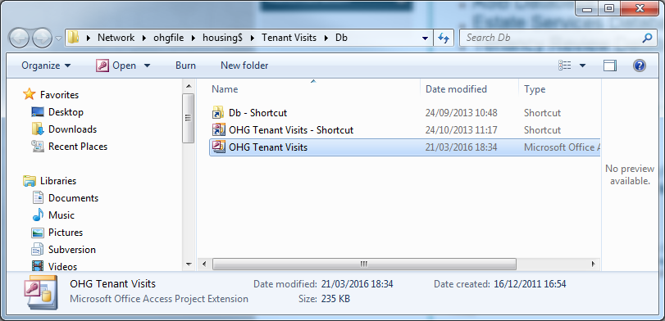

1. Back-end: Sql Server > ohg2k5sql01 > mark > tvs% prefixed tables, views etc.

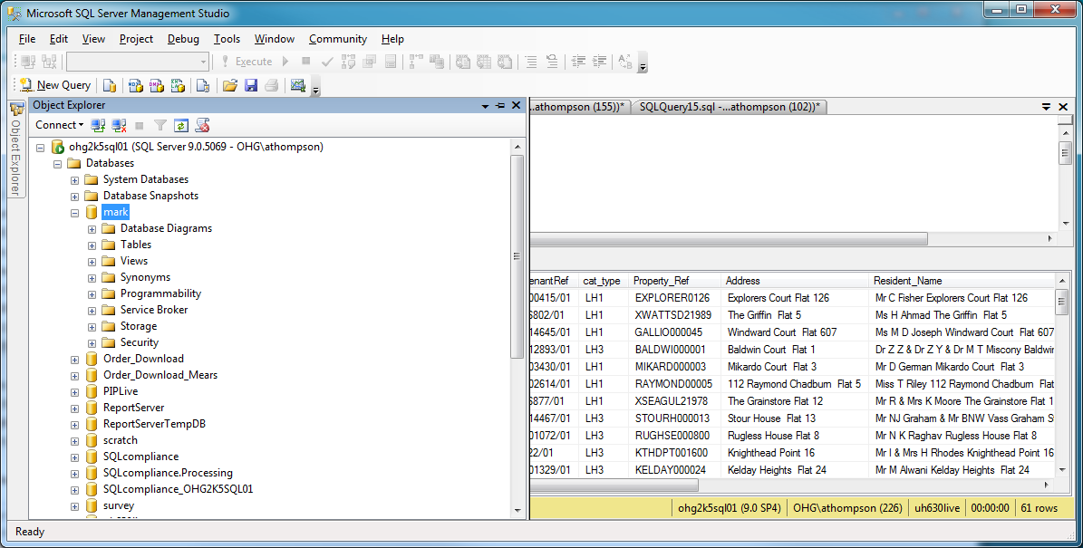

Main tables you need are:

3.1) tvsVisits – this is the main ‘single’ record for an tenancy visit and is the result of a visit having taken place, before that you need to look at the view:

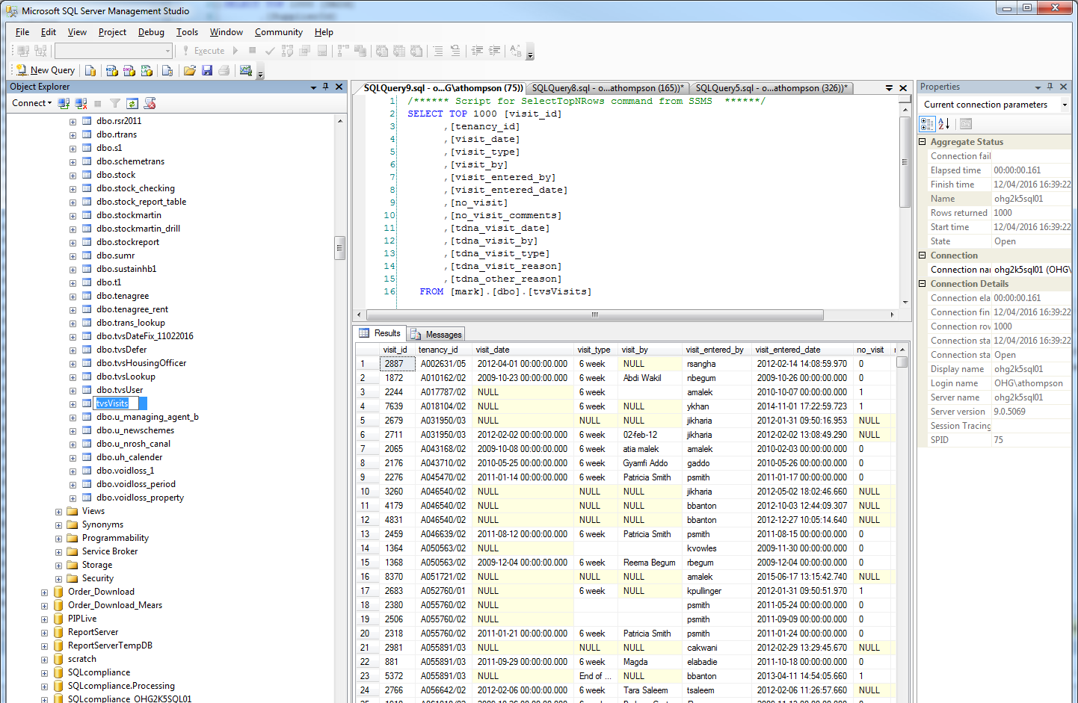

And view (ie behind the front-end view…)

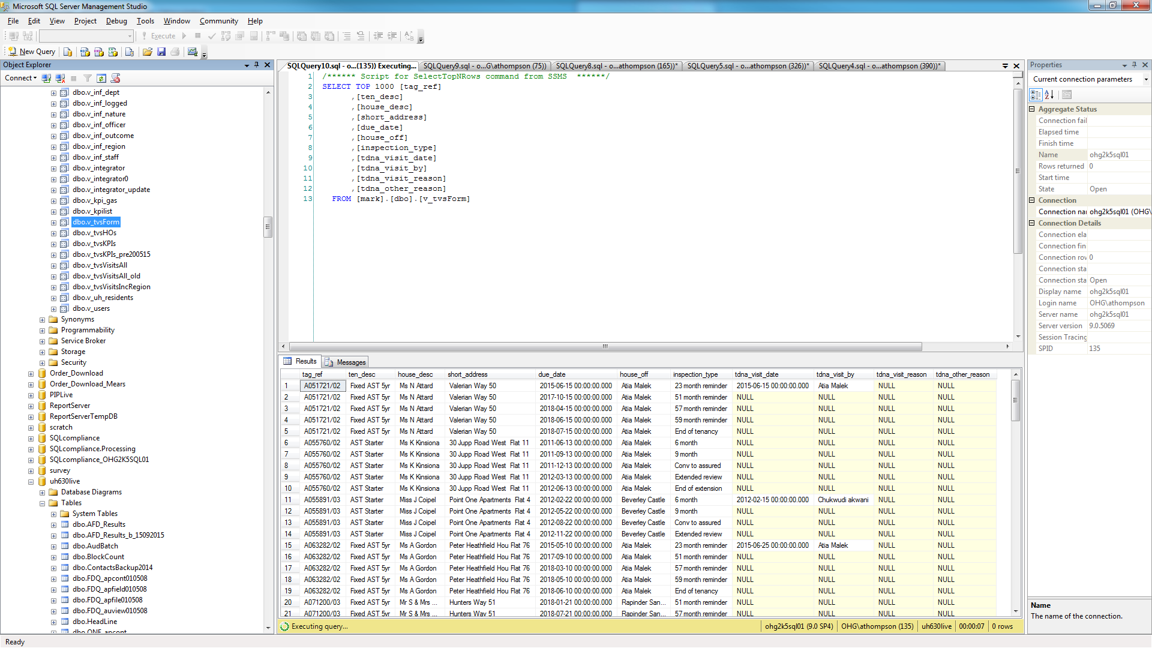

**You should note** this sql back-end is quite badly designed in the sense of normal form. It is not in 3NF (3rd Normal Form) and is quite denormalized really. There are also some hard coded lookups in the access db itself, which when found have been replaced with sql controlling tables. However, not done fully due to the fact this was only a temporary solution. It is not 3NF by any means.

1. New development work on the access database or amendments, fixes and admin changes.

To develop, copy the db below to your local machine and make changes. Tip – you may find you open the db and it says ‘read only’ whereby you could not amend the vba/forms etc. However, if you make another copy of this file on your pc, the 2nd copy will allow write access to make your changes.

NB: you should ignore all the other files here unless stated. That is for the team alone. You should however, ensure that there are not multiple versions of the db on this drive. The Tenancy visits db in particular is prone to having multiple non-actual version here. So a tidy up every 6 months should remove the non-actual one.

1. Script: VBA

To develop the VBA – on the local copy,

Updating the live access db: Copy across and overwrite the live copy.

Note: the VBA is pretty straight forward – if you can do VBA so this specification is NOT going into any tutorial on updating or amending current VBA. It is however a fact that any sql insertion of form data via this front-end of access – will require a fair bit of VBA to be replicated for the new aspect.

**ENSURE** you take a backup of the live one just in case before you overwrite, or if you have made changes that affect the live system, you will need to replace your defect copy with the original, then redevelop to fix improper changes.

1. User setup

Users may email you or the Sn or ICT helpdesk, or call them and be referred to you. This is a support matter really and so helpdesk should do it by using the method below by updating the sql table directly:

7.1) first check the user does not already exist. This is a primary key on the table so don’t add if already there, or the db will not work. 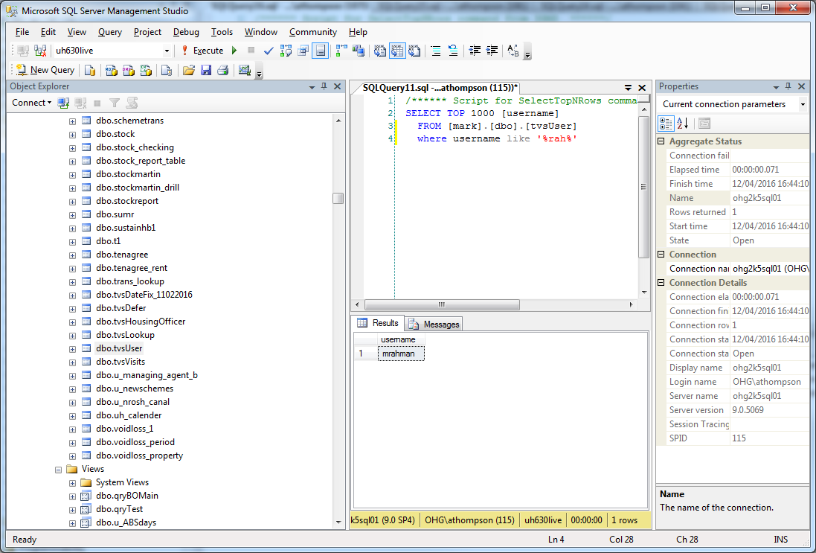

7.2) then if they DO NOT, you can add them. The username which is in the ‘login’ field is a PK or at least must be unique, so duplicates are not allowed hence the self service failure reasons. If they can be added, right click the tvsUser table as shown here, to edit the table.

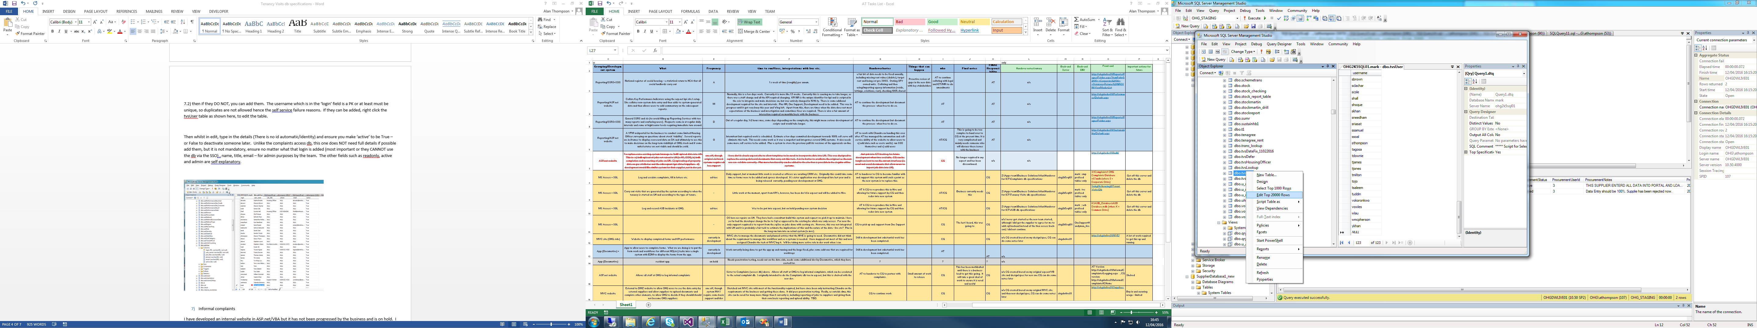

1. Hub links

